Task 2 – Planning & Designing a Procedural Programming Application
The documentation provided by the client does not contain enough information about the application requirements. You have been asked to interview the client to gather further information about the application requirements and produce a simple design document. The design document should clearly outline the required inputs, processing taking place, and desired outputs.

Student Certification Processing Application intends to read and analyze provided student academic performance data, generate an academic report for every student and write it into an individual output file in xlsx format.
The core logic of the application is located in the Student_Certification.py file. This file includes a list of functions intended to read, analyze input data, generate academic report outputs and store them in the /output folder. Main() method is an entry point to this script. This method stores paths to the input and output files, assessmentResults dictionary, which is the main data storage used across the script, and calls helper methods that actually perform all the tasks required to read, analyze input data and generate output.
The sequence of executing helper methods inside the script is the following:
- readAssessmentResults() method executes the first. This method tries to open input file with the provided file path (it’s currently located as "input_files/Assessment Results.csv") and tries to read it line by line. From the first line, it grabs course modules names and stores them in the courseName list. Next, it tries to read the file from the second row. For every row, it grabs student name, grades for every course and tries to figure out whether student passed the course. Then, method stores parsed data in the passed assessmentResults dictionary, using studentName as a key. Method also add empty placeholders for ‘cloudCert’ ‘optionCert’ and ‘overallScore’ values. Process repeats until it reaches the end of the input file. In the end, method returns modified assessmentResults dictionary.
- readIndustryCerts() function is the method in the execution flow sequence. This method tries to open file with the industry certification results (it’s currently located as "input_files/Industry Cert Results.csv"") and reads the file line by line. Method parses every line, trying locate student name and it’s industry certification results. Once located, method updates every student entry in the passed assessmentResults dictionary, using studentName to find exact student entry and modifying it’s ‘cloudCert’ ‘optionCert’ values. In the end, method returns modified assessmentResults dictionary.
- calculateOverallScore() is executed next. This method reads through the passed assessmentResults dictionary. For every entry in the dictionary, method reads through every assessment result, then it calculates and updates ‘overallScore’ value for every student. This iteration continues for every student entry in the dictionary. In the end, method returns modified assessmentResults dictionary.
- On the last stage, script iterates over the dict of assessmentResults. For every student entry in the dictionary, generateXlslFile() function is called. Function receives studentResults and student name, uses them to generate an xlsx output with openpyxl library. Once desired output generated, function stores the created file in the /output folder. Each student gets a dedicated report, with the student name added to the output file name.

I also provide the following screenshots to this documentation:

- Input Assessment Results.csv file:

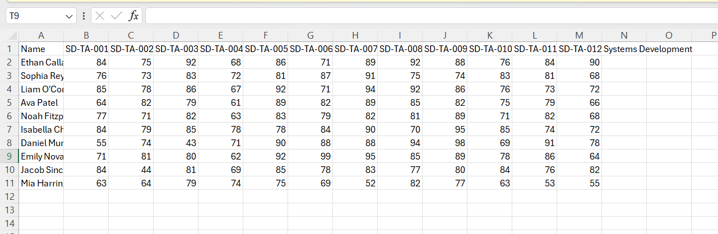

- Input Industry Cert Results.csv file:
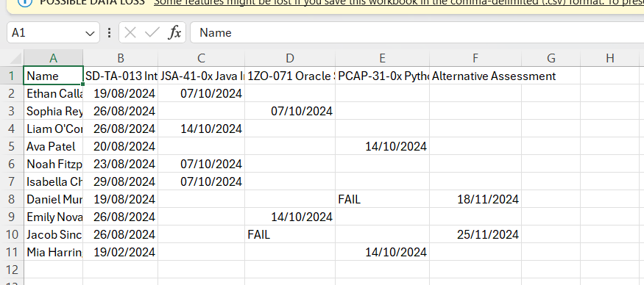

- assessmentResults dictionary structure:

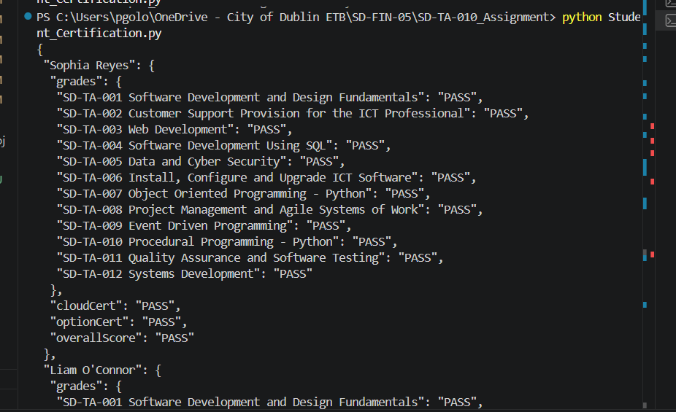

- Example of the output file

